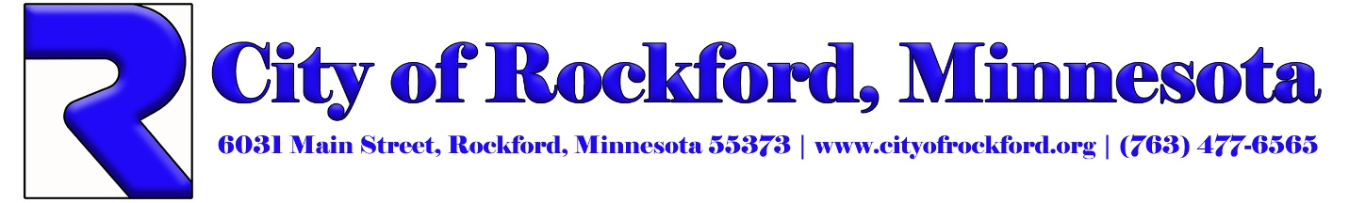

NOTICE OF PUBLIC ACCURACY TEST

NOTICE is hereby given that the Public Accuracy Test of the Voting Equipment to be utilized for the City of Rockford’s Primary Election on August 13th, 2024, will be held in the City of Rockford, Wright County, Minnesota, on Thursday, July 25th, 2024 at 8:00 a.m. in the Council Chambers, 6031 Main St.

Representatives of all political parties, candidates, the press and the public are invited to attend.

Debbie Buoy
City Clerk/Assistant City Administrator
6031 Main Street Rockford, MN 55373
Phone: 763-634-8770 Ext 2
Email: debbieb@cityofrockford.org

Published: July 18th, 2024 -Crow River News
Posted: July 9th, 2024

